ANNEX C
Memorandum
North Blackburn Scheme

Economic Outputs Assessment
As part of our assurance of the SOBC documentation, a review was undertaken of the economic outputs that were provided to support the Economic Case.
A short summary of our review is provided below, indicating:
- What each output represents;
- Which specific sites are in scope;
- The basis of the calculations for each output;
- How the economic outputs will be delivered;
- Monitoring and evaluation arrangements; and
- Certainty of delivery.

Economic Outputs
The following outputs have been assessed as part of the North Blackburn Scheme, reflecting the requirements of the LEP:
- Housing Units;
- Private Sector Investment;
- Jobs;
- Commercial Floor Space; and

- GVA.

The North Blackburn scheme is forecast to directly unlock two nearby housing sites, both of which access the A6119 in the vicinity of the scheme, as shown on the plan overleaf:
- North Blackburn - Phase 1 Whinney Lane (label 7 on the schematic); and
- Roe Lee - Phase 1 North Site (label 3).

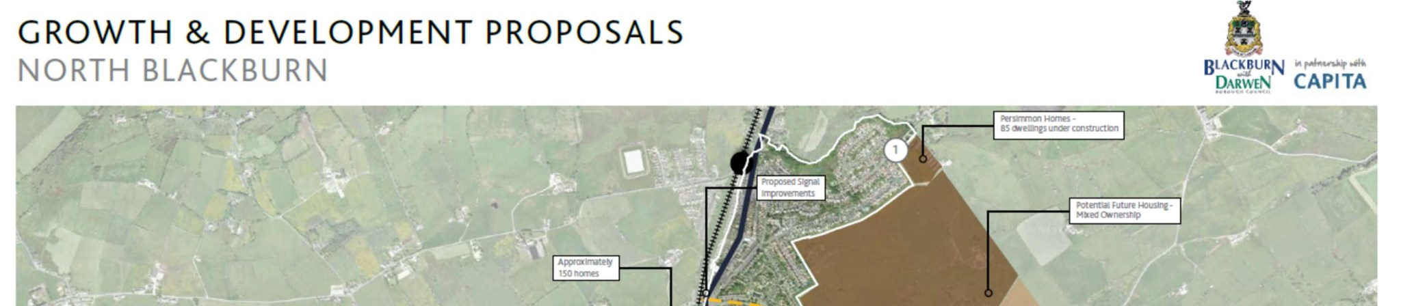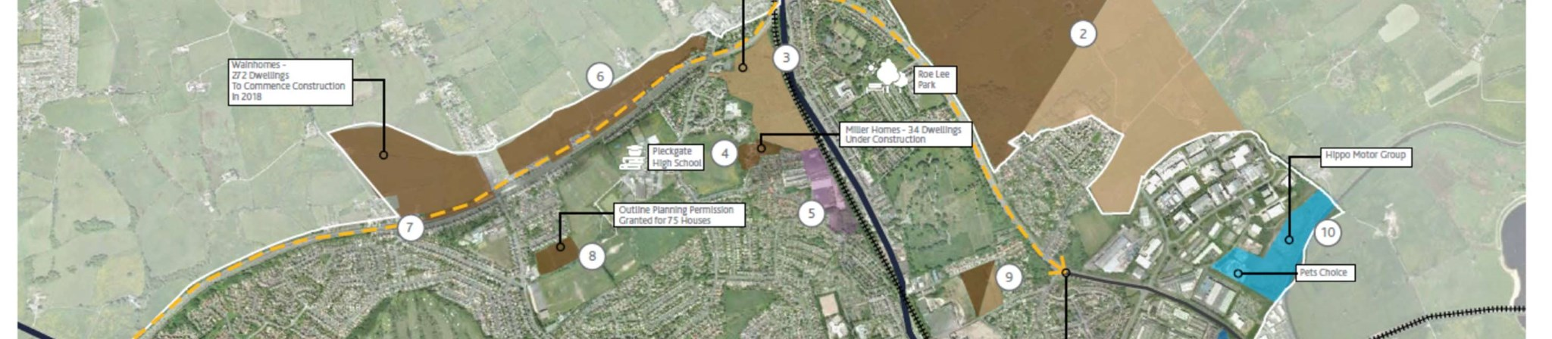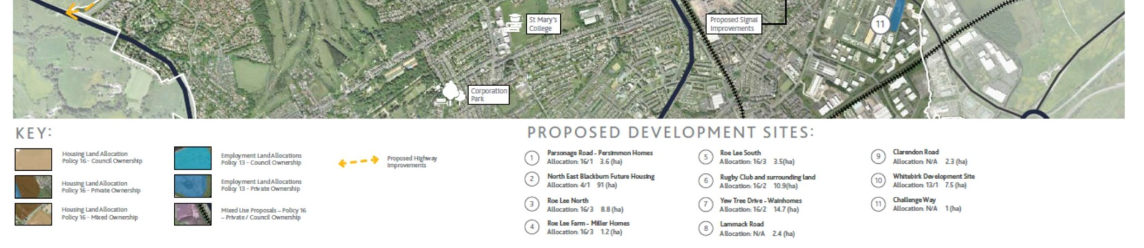
Jacobs U.K. Limited

Memorandum

1 City Walk
Leeds, West Yorkshire LS11 9DX
United Kingdom
T +44 (0)113 242 6771 F +44 (0)113 389 1389 www.jacobs.com

Calculations
The assumptions for each site are shown in the table below:
Table C1 – Development sites dependent on the North Blackburn Scheme

Development | Area  (Ha) | No. Housing  Units | Opening  Year
North Blackburn - Phase 1 Whinney Lane | 4.86 | 272 | 2024
Roe Lee - Phase 1 North Site | 9.66 | 155 | 2022

BwDBC have provided the assumptions around how many houses each development site will accommodate and the opening year.
Gross Value Added (GVA) has been calculated for both a ‘with scheme’ and ‘without scheme’ scenario, with the difference between these scenarios then being reported as the GVA impact of the scheme. The following assumptions and parameters have been used in calculation of the GVA benefits:

• | GVA benefit per housing unit: | £10,170 per annum
• | GVA benefit per job created: | £20,340 per annum
• | Discount rate: | 3.5% per annum
• | Appraisal period: | 60 years

The GVA appraisal tables, showing GVA per year and split by site, are provided as Appendix G to the BCR Technical Note (which forms Appendix C to the SOBC).
Applying the discount rate to the difference between the ‘with scheme’ and ‘without scheme’ GVA scenarios gives a total GVA benefit associated with the North Blackburn scheme of £17m.
Delivery and Certainty
The calculation of economic benefits relies on assumptions about investments made by private companies in the future. These assumptions are therefore necessarily subject to uncertainty. In order to best assure the validity of the economic outputs, it is therefore important to base assumptions on the best available data, informed by local knowledge of the appetite of private developers for investment.
The forecasts made by Capita for the economic outputs of the scheme have been developed on the basis of close collaboration with Blackburn with Darwen Borough Council, who in turn have been informed of the intentions of the private developers delivering the two sites through the planning application process. This is the best information available with which to forecast GVA, and Jacobs are satisfied that the forecast represents a sound estimate of the most likely outcome. Although it is not possible to provide a definitive statement about the certainty of the outputs being accurate, due to the committed status of one of the developments and the recommendation for approval for the other by committee on the 20th December 2018, as well as the achievable assumed completion dates of the two sites, it is likely that they will be realised.

Monitoring and Evaluation
A Monitoring and Evaluation Plan has been developed by Capita for the North Blackburn scheme, and forms Appendix E to the SOBC.
The Monitoring and Evaluation section of the SOBC (section 5.8) summarises the range of metrics which BwDBC aim to assess. The following metrics are relevant to the economic outputs section;
- Housing unit starts (annual): rate of delivery to be monitored and reported.
- Housing unit completed (annual): rate of delivery to be monitored and reported.
In addition, the Monitoring and Evaluation Plan makes clear that these metrics will be specifically monitored for the development sites identified as being dependent on the scheme.

